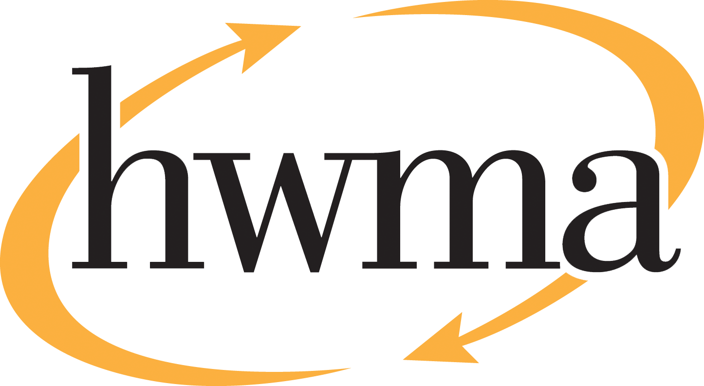
BOARD OF DIRECTORS
Stacy Atkins-Salazar, City of Arcata, Chair
Michelle Lewis-Lusso, City of Blue Lake, Vice Chair
Leslie Castellano, City of Eureka
Randall Cady, City of Ferndale
Steve Madrone, County of Humboldt
Frank Wilson, City of Rio Dell

Minutes
Thursday, September 10, 2026, at 5:30 PM
Eureka City Council Chamber

Present: Stacy Atkins-Salazar, Michelle Lewis-Lusso, Leslie Castellano, Randall Cady, Steve Madrone, Frank Wilson.
Absent: None
Staff: Eric Keller-Heckman, Tony Heacock, Helder Morais, Hilary Schwartz
Legal Counsel: Nancy Diamond

- Call to Order and Roll Call at 5:30 PM

Chairperson Atkins-Salazar called the meeting to order at 5:30 PM. A quorum was present and acting.

- Consent Calendar
  - Approve Minutes from the August 13, 2026, HWMA Board of Directors Meeting
  - Review and Approve Draft June 2026 Financial Reports
  - Approve Request for Proposal for Hazardous Waste Transportation and Disposal Services
Chairperson Atkins-Salazar inquired if there were any requests to pull items from the Consent Calendar. Director Lewis-Lusso responded that she would like to pull Item C of the Consent Calendar for discussion.

Chairperson Atkins-Salazar opened the floor to public comment on the Consent Calendar, and no public comment was received.

Chairperson Atkins-Salazar closed the floor to public comment.

Motion: Director Castellano motioned, and Director Cady seconded, to approve items a) through b) of the Consent Calendar as delivered
Action: Approve the Motion as made by Director Castellano and seconded by Director Cady
Ayes: Unanimous
Noes: None
Absent: None

Director Lewis-Lusso requested clarification about discrepancies she observed in the titles in the Request for Proposals compared to the agreement attached to the proposal, which reflects the name of the disposal firm currently under contract for the hazardous waste transportation and disposal services. Executive Director Keller-Heckman explained that the attached agreement is only a draft, not a finalized version, intended as a placeholder to show potential proposers what the contract would look like. The finalized version of the contract will be altered to include details specific to the successful proposer and the agreed-upon services. Director Lewis-Lusso indicated that the additional discrepancies she noted in the RFP with respect to insurance and liabilities would also be reconciled in the finalized version of the contract. Executive Director Keller-Heckman confirmed that the additional discrepancies noted would also be updated in the finalized version of the contract. Director Castellano added that hazardous waste transportation and disposal services are highly specialized, and there is likely a short list of potential proposers for this RFP.

Chairperson Atkins-Salazar opened the floor to public comment on Item C of the Consent Calendar, and no public comment was received.

Chairperson Atkins-Salazar closed the floor to public comment.

Motion: Director Castellano motioned, and Director Lewis-Lusso seconded, to approve item c) of the Consent Calendar as delivered
Action: Approve the Motion as made by Director Castellano and seconded by Director Lewis-Lusso
Ayes: Unanimous
Noes: None
Absent: None
- Oral and Written Communications

Chairperson Atkins-Salazar opened the floor to public comment regarding items not on the agenda, and no public comment was received.
Chairperson Atkins-Salazar closed the floor to public comment.
- Receive Update on Strategic Vision Timeline and Pathway

Executive Director Keller-Heckman provided an update to the board on the timeline and pathway for the Strategic Vision plan. In February 2026, the HWMA Board expressed interest in a strategic vision workshop and plan, including development of a document that would better define goals and objectives for the Authority to work towards in the future. At its February meeting, the board established a Strategic Vision ad-hoc committee, which met with staff the following month to discuss the broad goals and desired intent of the process. This meeting resulted in a high-level outline of short- and long-term planning goals, which were presented to the full board at the March regular meeting. The board directed staff at that time to initiate the strategic vision project and procure a consultant to lead it.

Staff solicited several consultants in the area and determined that Kraft Consultants had the necessary skills and availability to take on the project within the board’s desired timeline. Kraft Consultants is highly regarded locally and has extensive experience working with both public and private sector entities in Humboldt County, including some of HWMA’s member agencies. Kraft Consultants is available to begin in late September and anticipates the process will take 6–8 months, depending on stakeholder availability. Kraft Consultants recommends beginning the project with a large roundtable workshop including the HWMA ad-hoc committee, HWMA management staff, high-level jurisdiction staff, and other stakeholders, such as franchise haulers and other waste-adjacent local entities.

The information gleaned from the workshop will be used to develop a series of interview questions. Interviews will be informal in nature and take place in either one-on-one or small group settings. Additionally, Kraft Consultants will conduct market research and collect data from similar entities in the waste and recycling industry to develop a baseline of current standard practices. The board will then receive this information and provide direction to develop a draft strategic vision plan along with staff. The draft plan will be circulated to member agency staff for final input and then brought before this board one more time for final approval. It is anticipated at this time that interviews and research will take place between November and January, so the board could potentially see results in February 2027 with final adoption of the plan in April 2027.

The projected cost of the project is $19,500 and is currently unfunded and unbudgeted in Fiscal Year 2026–27. Typically, staff budgets for miscellaneous consulting services and would recommend placing the costs of the strategic vision project within the Admin-Consulting line of the currently adopted budget. Director Castellano inquired about how input from members of the public would be included in the strategic vision planning process. Executive Director Keller-Heckman responded that Kraft Consultants had proposed a few different ways to approach public input. One option is to include the full HWMA Board in the roundtable workshop, making it a Brown Act meeting open to public comment. Director Castellano inquired if the other board members would be comfortable with only the ad-hoc committee attending the roundtable workshop as opposed to the full board. Director Madrone responded that he was comfortable with the ad-hoc committee continuing to take the lead and that he was confident that there would be sufficient opportunities for participation in the strategic vision plan. Director Lewis-Lusso indicated that she too was comfortable with her current level of participation.

Chairperson Atkins-Salazar suggested that staff consider agendizing a presentation by Kraft Consultants at a future board meeting and advertise the meeting as a time for public comment on the strategic vision process. Chairperson Atkins-Salazar also inquired if there were sufficient funds in the Admin-Consulting line item of the budget to cover the cost of Kraft Consultants’ proposal, or if the unbudgeted cost would impact other planned expenses. Director Schwartz concurred with Executive Director Keller-Heckman’s assessment that the Admin-Consulting funding was typically unallocated when the budget is adopted, and that the $15,335 remaining in that line item was not currently committed to other projects. Executive Director Keller-Heckman added that a mid-year budget adjustment could be proposed to cover the full costs of project if necessary.

- Standing Item: Board Member Reports
Director Wilson reported that Caltrans is tearing down an older bridge that crosses the Eel River on Highway 101 just north of Rio Dell. Northbound and southbound traffic has been re-routed to single lanes in both directions on the southbound bridge crossing. The project includes a seismic retrofit and is expected to last approximately four years.

- Standing Item: Executive Director’s Report

Executive Director Keller-Heckman had nothing further to report.

- Report Out of Closed Session: It is the intention of the Board of Directors to meet in closed section for one item: Public Employee Performance Evaluation – Executive Director, pursuant to Government Code §54957.

Chairperson Atkins-Salazar opened the floor to public comment regarding closed session. No public comment was received.

Chairperson Atkins-Salazar adjourned the meeting to closed session at 5:46 pm.

Chairperson Atkins-Salazar called the meeting to order from closed session at 7:42 pm.

No Report Out from closed session was required.

- Adjourn

Chairperson Atkins-Salazar adjourned the meeting at 7:21 pm following closed session.

